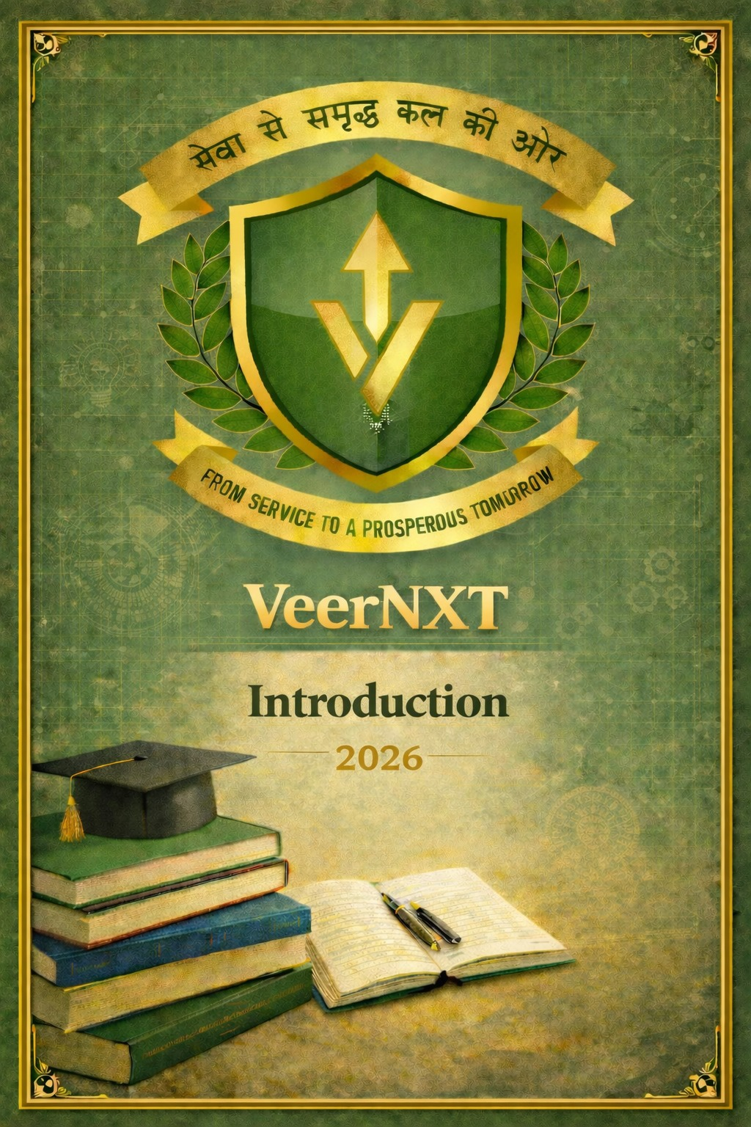

SSC STENOGRAPHER (GRADE ‘C’ & ‘D’)
The Staff Selection Commission (SSC) conducts this open competitive examination for the recruitment of Stenographer Grade ‘C’ (Group ‘B’, Non-Gazetted) and Stenographer Grade ‘D’ (Group ‘C’) for various Ministries, Departments, and Organizations of the Government of India.

1. Overview of Selection Process
The selection process for SSC Stenographer is unique as it does not have a CBT II (Second Tier objective exam). Instead, it focuses heavily on shorthand skills.
- Stage I: Computer Based Examination (CBE): A single-tier objective-type online test.
- Stage II: Skill Test in Stenography: A mandatory practical test where candidates must take dictation and transcribe it on a computer. This stage is qualifying in nature.
- Stage III: Document Verification (DV) & Medical Examination: Final verification of eligibility and fitness as per the standards of the allocated department.

2. Education & Age Eligibility
- Educational Qualification: Candidates must have passed the 12th Standard or equivalent examination from a recognized Board or University.
- Age Limit:
  - Stenographer Grade ‘C’: 18 to 30 years.
  - Stenographer Grade ‘D’: 18 to 27 years.
  - Standard relaxations: OBC (3 years), SC/ST (5 years), and PwD (10 years).

3. Detailed Syllabus for CBE
The Computer Based Examination consists of one paper with 200 questions for 200 marks, to be completed in 2 hours.

A. General Intelligence & Reasoning (50 Questions | 50 Marks)
- Verbal & Non-Verbal: Analogies, Similarities and Differences, Space Visualization, Problem Solving, Analysis, Judgment, Decision Making, Visual Memory, Discriminating Observation.
- Logical: Relationship concepts, Arithmetical reasoning, Verbal and Figure classification, Arithmetical number series, Non-verbal series.
- Abstract: Coding and Decoding, Statement Conclusion, Syllogistic reasoning.

B. General Awareness (50 Questions | 50 Marks)
- Current Events: National and International importance, Sports, Awards, and Honors.
- Static GK: History, Culture, Geography, Economic scene, General Polity including Indian Constitution, and Scientific Research.
- Social/Environmental: Matters of everyday observation and experience in their scientific aspects.

C. English Language & Comprehension (100 Questions | 100 Marks)
- Grammar: Correct usage of language, Writing ability, Sentence Structure, Parts of Speech, Tenses, Active/Passive Voice, Direct/Indirect Speech.
- Vocabulary: Synonyms, Antonyms, Idioms & Phrases, One-word substitution, Cloze Test.
- Comprehension: Understanding of passages and the ability to draw conclusions.

4. Stenography Skill Test (Qualifying)
Candidates who clear the CBE cut-off are called for the Skill Test. Candidates are given one dictation for 10 minutes in English or Hindi (as opted) at the following speeds:
- Stenographer Grade ‘C’: 100 words per minute (w.p.m.).
- Stenographer Grade ‘D’: 80 words per minute (w.p.m.).
Transcription Time on Computer:
Post | Language | Transcription Time
Steno Grade 'D' | English | 50 Minutes
Steno Grade 'D' | Hindi | 65 Minutes
Steno Grade 'C' | English | 40 Minutes
Steno Grade 'C' | Hindi | 55 Minutes

5. Physical Standards
Physical standards are generally not required for most clerical Stenographer posts. However, for specific roles in the Border Roads Organization (BRO), male candidates must meet physical requirements:
- Height: Minimum 157 cm (relaxable for specific regions/tribes).
- Chest: 75 cm (+5 cm expansion).
- Physical Efficiency: One-mile run (1.6 km) to be completed within 10 minutes (Qualifying).

Key Benefits for Agniveers

The SSC Stenographer Grade C & D exam is a unique choice for an ex-Agniveer because it is one of the few SSC exams that transitions you from a "field-based" military role to a high-level "office-based" secretarial role in Central Ministries.
Since this exam has no Physical Efficiency Test (PET) for 99% of the posts, your military background gives you a significant advantage in discipline and focus for the crucial Skill Test (Shorthand).

1. Age Relaxation Benefits
The standard age limit for SSC Stenographer is 18–30 years (Grade C) and 18–27 years (Grade D). As an ex-Agniveer, you receive:
- First Batch (2026 Exit): An upper age relaxation of 5 years.
  - Grade C: Eligible up to 35 years.
  - Grade D: Eligible up to 32 years.
- Subsequent Batches: An upper age relaxation of 3 years.
  - Grade C: Eligible up to 33 years.
  - Grade D: Eligible up to 30 years.
- Calculation Rule: You can deduct your 4 years of service from your actual age. If the resulting age is within the limit, you are eligible.

2. Reservation Quotas (10% Group C)
Almost all Stenographer Grade D posts and many Grade C posts fall under the Group C category in various Ministries (like MEA, Income Tax, and Railways).
- 10% Reserved Vacancies: 10% of total vacancies in Central Government departments are reserved for ex-Agniveers.
- Lower Cut-offs: Because you compete only within the reserved Agniveer pool, the marks required to clear the Computer Based Examination (CBE) are significantly lower than those for General category candidates.

3. Physical & Skill Test Advantage
The SSC Stenographer exam is purely based on academic and technical skill:
- Physical Standards: Unlike GD or CPO, there is no running, jumping, or physical test for these posts (except for rare vacancies in the Border Roads Organization - BRO).
- Skill Test Exemption (BRO Only): For the few posts in BRO that require physical standards, ex-Agniveers are exempted from the Physical Efficiency Test (PET).
- Discipline Advantage: The Stenographer Skill Test (Shorthand) requires 6–8 months of dedicated daily practice.

6. Important Links for Candidates
- Official SSC Website: ssc.gov.in
- Candidate Dashboard: ssc.gov.in/login

